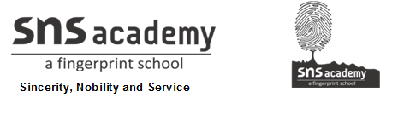

Marks obtained:

Total:
30
MONTHLY TEST NOVERMBER- 2019
Name: ____________________________
Grade: I Section___
Subject: EVS
Date: 04.11.19
Time: 1 Hour

I. Choose the best answer. 5x1=5
- We get rice from______________ .(animal / plants)
- _______________(milk / apple)is an animal food.
- The food that can be eaten raw is____________(cucumber / chicken)
- The main source of water is _____________ (rain / pond).
- .we get underground water from_______________(sea / well).
II. Write weather the statements are true or false. 5X1=5
6. Pulses are got from plants._______________
7. Coco cola is a healthy food._______________
8. We should not waste food.________________
9. The water in the sea is fresh water.______________
10. We use water to cook.____________

III. Write two examples for the following. 3x2=6
11. Animal food _____________ _________________
12. Body building food__________________ _______________
13. Sources of water ________________ __________________
IV. Answer the following. 2X2=4
14. Why do we need food?
____________________________________________________________________________________________________________________________
15. Is junk food good for our health? Why?
____________________________________________________________________________________________________________________________
V. Categorize the following. 4x1=4
Chips orange nuts ice-cream
Healthy food | Junk food

VI. Draw a word web for uses of water. 6
